**Data Structures**

**Assignment #2 (To be done in groups of 4)**

**Due Date: 9th April 2021 11:30pm**

In this assignment you must modify the code for a basic equipment shop menu and player interactions in a game.

A player character uses the menu to buy items from the shop and place in their backpack. The player starts off with a fixed amount of money and as they buy items, the bought items must go into their backpack.

The items(Weapons) in the shop must be implemented using a hash table that implements **quadratic** probing.

The maximum number of **different** **types of items (weapon types)** the shop can hold is 80. **There can be any number of items of a specific type in the store.**

A player **cannot** buy an item if :

* They do not have enough coins to buy it.
* The backpack will be overweight if bought.
* The backpack is full.

Partial UML diagram for the relationship between the Player, backpack and items (weapons).

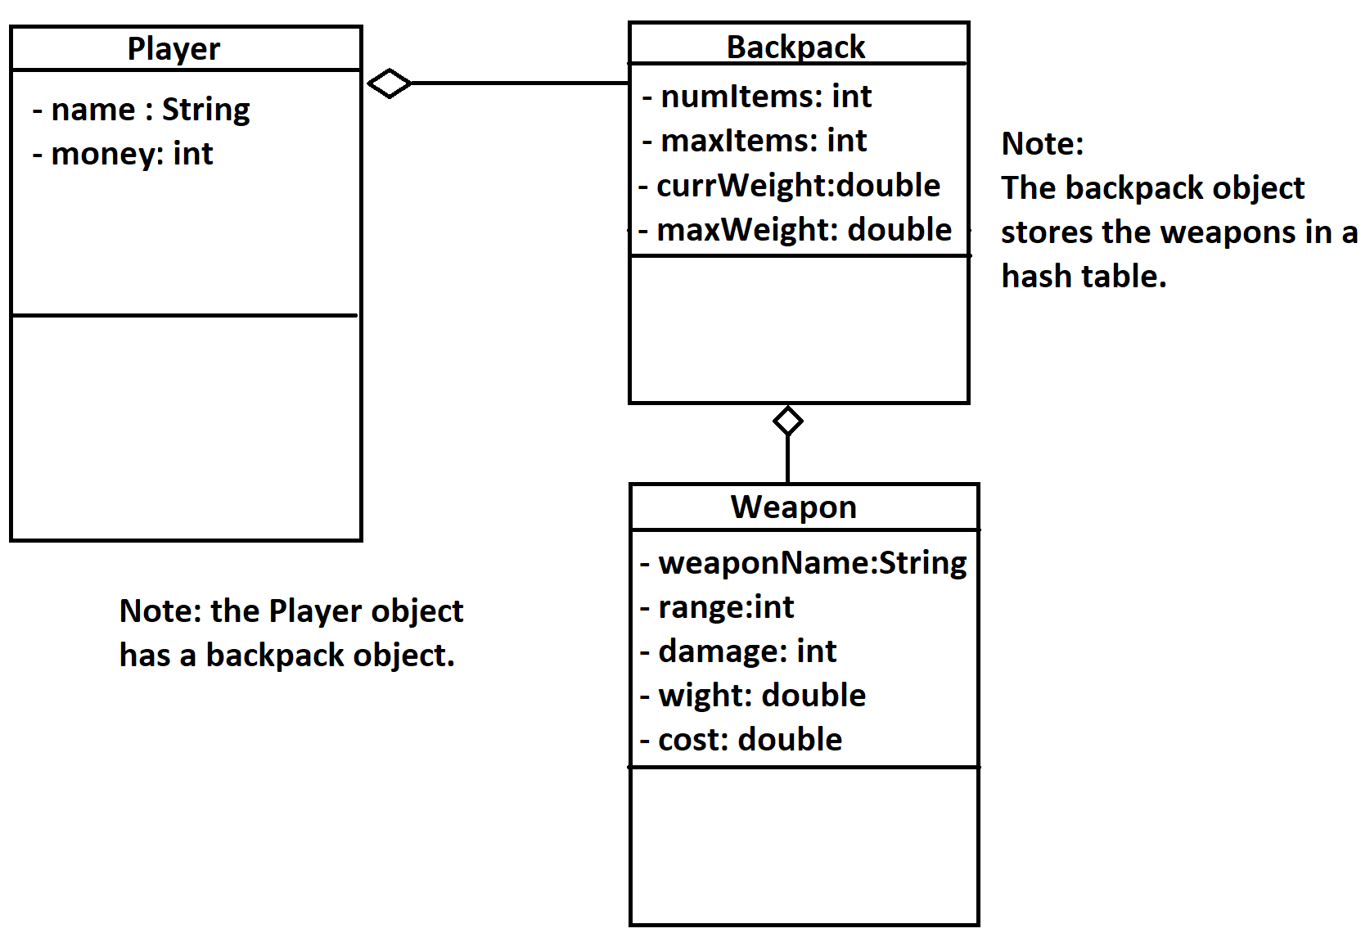

The player always starts off with 45 coins.

The backpack must be implemented as an object and uses a hash table implemented as **separate chaining** to hold the items (weapons) bought.

The maximum number of items a backpack can hold is 30.

The maximum weight a backpack can take is 90 pounds.

In your main program, you must ask the user for a name for the player.

After creating the player, you must present a menu with functionality similar to what is show below:

1. Add Items to the shop
2. Delete Items from the shop
3. Buy from the Shop
4. View backpack
5. View Player
6. Exit

**Additional Information / Help**

|  |  |
| --- | --- |
| **Operations** | **Details** |
| Add Items to the shop | **Adds an items to the shop** |
| Delete Items from the shop | **Deletes items from the shop** |
| Buy from the Shop | **Allows the player to buy items from the shop. Only items that are in stock (have a quantity more than 0) should be displayed.** |
| View backpack | **A list of all the items in the player’s backpack.** |
| View Player | **When the player is viewed, the following must be shown:**  **The player’s name**  **The amount of coins (money) they have**  **A list of all the items in their backpack.** |
|  |  |

**When adding an item you should first ask for the name of the item.**

1. **A check should be made to see if an item with that name exits.** 
   1. **If it exists, the number of items of that type to add should be requested and added to the quantity in stock.**
   2. **If it does not exist, this means that a new item is being added to the shop and the following information must be requested:**
      1. **weaponName (String) , range (int), damage (int), weight (double), cost (double)**
      2. **The quantity of the item being added must also be requested and the item must be created and added to the hash table.**

**Marking scheme outline:**

**Part 1) (worth 50% of the marks)**

* **Fully functional hash table for the shop items.**

**Part 2: (worth 30% of the marks)**

* **Fully working backpack (hash table)**

**Part 3: ( worth 15 % of the marks)**

* **The fully working menu operations (will all constraints met)**
* **Complete classes**

Submission Requirements:

**The Student ID number for each member of the group must be commented at the top of the file.**

**Choose one member of the group to make submissions on behalf of the group.**

**The chosen member can make as many submissions (versions) as they like. Only the last submission will be marked.**

**You must upload 1 item :**

**The completed submission document .**